GREEN THUMB

Kristina Kovaleva

Michelle Trimpin

Juhi Sattar



Paul Davison

A WEB APP FOR LAWN SERVICE COMPANIES

**System Requirements**

● Latest Installment of Java (Java 8.0)

● Windows (7, 8, or 10) OR Mac OS X

● Stable Internet connection

**Installation**

There is no necessary download or installment needed for using Recipe Manager. There will be a link provided to access Recipe Manager once it has been developed.



User Guide

This guide is intended for users who have already followed the provided link to GTLSS. If you are reading this section but have not navigated to the web-application by clicking the link to GTLSS yet, please refer to the Installation instructions provided in this guide.

Admin User

**Admin Login**

As Admin User of the E-commerce web application, you will be able to access the Admin Portal that will allow administration of business-related database. Through the Admin Portal, you will be able to manage your employees, equipment, lawn services and products.

* On the Home Page, you (the Admin user) should click on the "Admin Portal" button, which will redirect you to the Admin Login page.

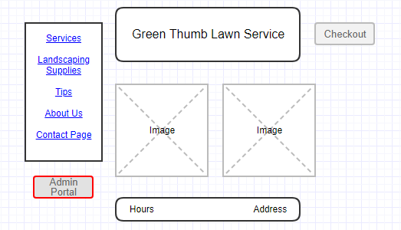

* On the Login page, you will have to provide the Admin username and password into the corresponding fields, and then click "Login" button.

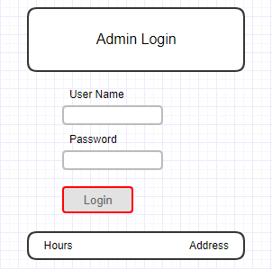

* On the Admin Portal page, you will be presented with a variety of administrative options that you may need to perform to manage your E-commerce business. This application comes with the following included administrative options;

1. Lawn Supplies
   * Add
   * Show
   * Update
   * Remove
2. Lawn Services

* Show
* Add
* Update
* Remove

1. Lawn Equipment

* Show
* Add
* Update
* Remove

1. Employees

* Show
* Add
* Update
* Remove

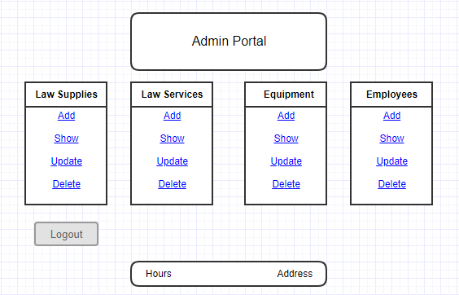

Note: This guide will provide instructions for adding, updating, and removing Supplies from the business-related database. The same instructions can be used to manage Services, Equipment, and Employees.

Warning: All modifications to the database data are final and cannot be reverted, so make sure you check all the selections and modifications before you finalize them by pressing the buttons Add, Show, Update, or Delete.

**Adding Supplies**

When Add Supplies is selected, the app will provide you with a form allowing you to add information about a new product (e.g. product name, path to the product image, product description, and product price). By entering the requested information and clicking Add button, you will be able to add a new product in the business-related database.

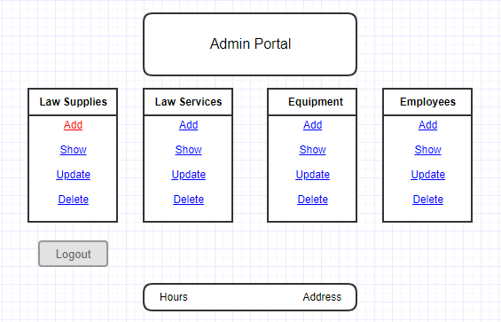

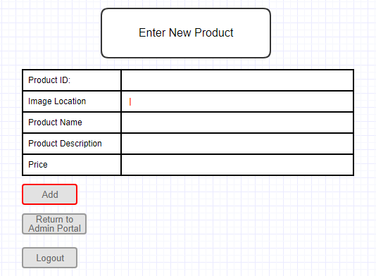

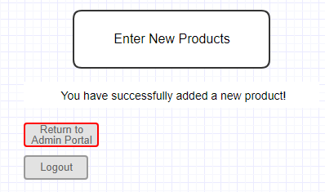

**Reviewing Supplies**

When Show Supplies is selected, the app will display all available supplies in the business-related database. This will allow you to review the product information and decide if anything needs to be updated in the Supplies database table.

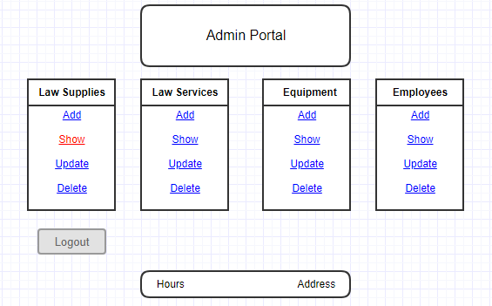

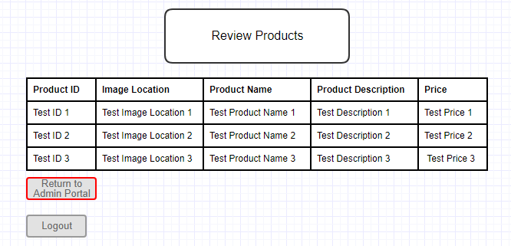

**Updating Supplies**

When Update Supplies is selected, the app will allow you to select what product you want to adjust. Then, you will be provided with a form showing current information for the selected product and allowing you to edit the information. After you complete editing the information, you should click on Update button, to finalize the changes.

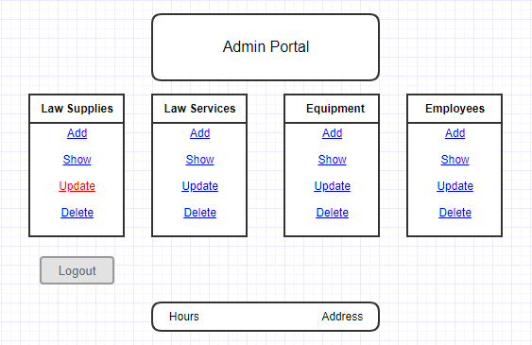

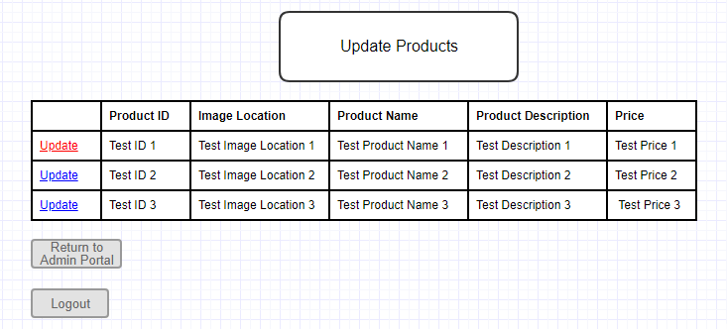

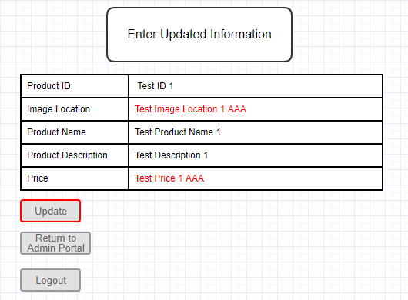

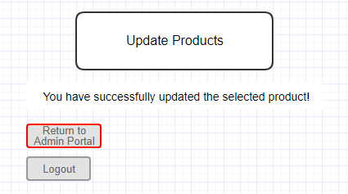

**Deleting Supplies**

When Delete Supplies is selected, the app will allow you to select what product you want to delete. Once you select the product, clicking on Delete button will finalize the deletion.

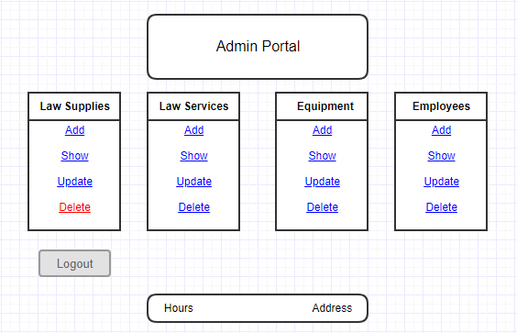

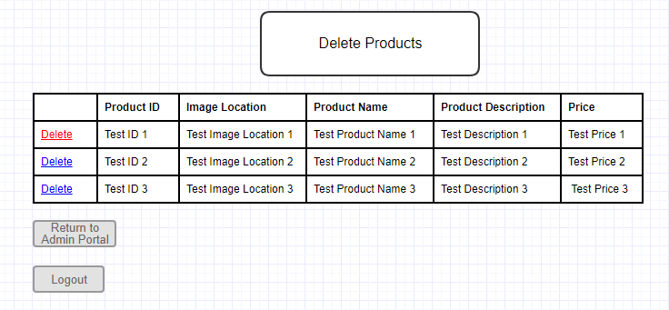

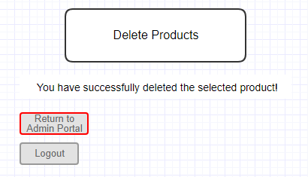

**Admin Logout**

Once you are done using the Admin Portal, you should click on the Logout button, which will securely log you out.

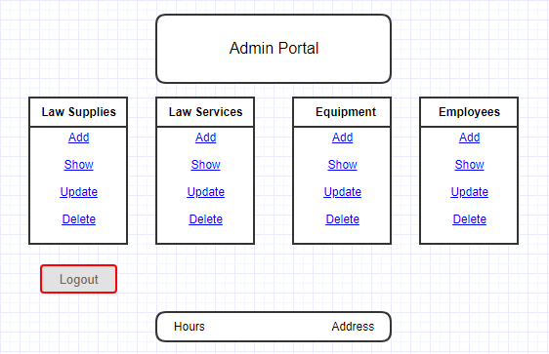

**Customer User**

**Tips Page**

On the Home Page, you should click on the "Tips" link, which will redirect you to the Basic Lawn Care Tips page.

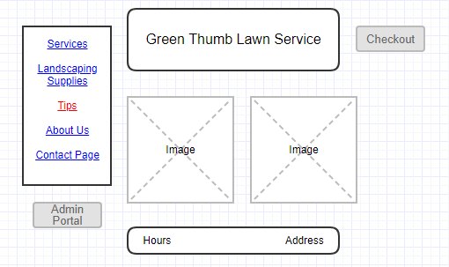

Landscaping Tips page displays lawn services tips (e.g. a. proper mowing, proper watering, best times for planting, tips for fertilization, tree trimming, etc.)

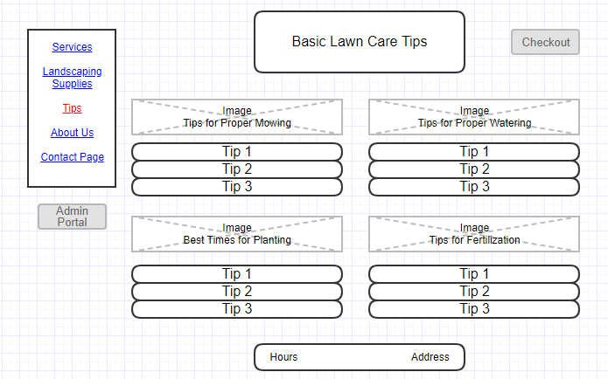

**About Us Page**

About Us page displays information about the E-commerce lawn services company (GTLSS), including a Company Bio, Honored employees, and Community Service.

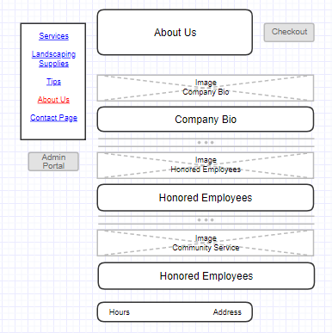

**Contact Us Page**

Contact page provides the option to write a comment or question and then email that to Customer Support of the Ecommerce lawn service company. You will have to provide your name, phone number, and email address into the appropriate fields. Once you finish writing your comment or question, click Send Email button.

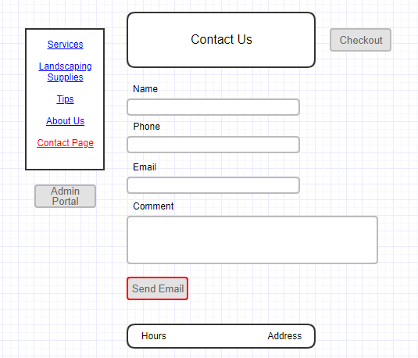

**Landscaping Supplies Paige**

Landscaping Supplies page allow you to selects the desired landscaping product and its quantity. Once you done with the selection, you should click the "Add to Cart" button. This will result in placing the selected supply order into the shopping cart.

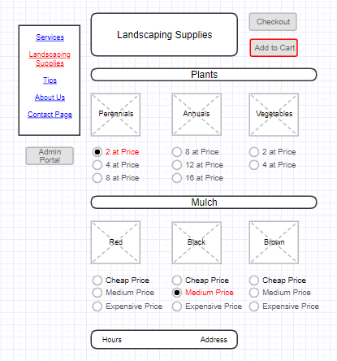

**Services Paige**

Services page allow you to selects the lawn service that fits your needs the best. Once you done with the selection, you should click the "Add to Cart" button. This will result in placing the selected service order into the shopping cart.

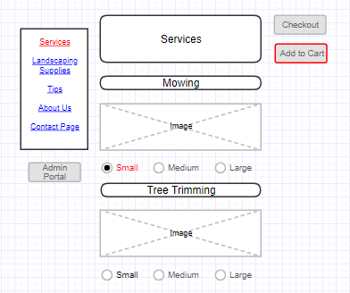

**Checkout**

Once you are done with browsing the website and making your selections, you can click the "Checkout" button available on all pages. This will redirect you to the Checkout page, where you will be presented with an itemized list of Services and Supplies requested.

If you did not order any services, you can skip the following step and go to the next one.

If you selected any lawn care services, you will be able to schedule the date for the service via this page. Just simply chose one of the available dates on the calendar, which fits your schedule the best.

After reviewing your order and (if applicable) selecting date of service, fill out the bulling form providing information like your name, email, address, credit cart type, number and expiration date.

When you are done with filling out your billing information, click on the "Submit Order" button.

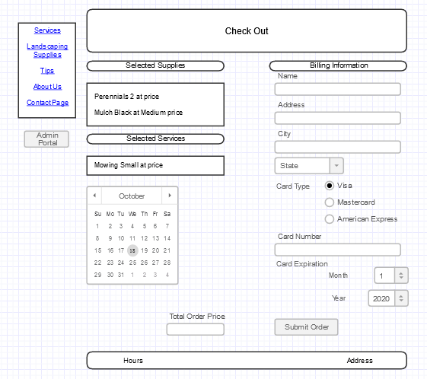

Once your payment information is verified, you will receive the order confirmation.

